**Twitter Analysis using R in Machine Learning Algorithms:**

**Steps:**

1. Twitter Data taken from online repository.
2. Loaded the necessary packages into the workspace

* library(twitteR)
* library(sentiment)
* library(plyr)
* library(ggplot2)
* library(wordcloud)
* library(RColorBrewer)

1. Performed Data Collection (harvested and binded text) from the tweets with the specific term “Starbucks” by using the function searchTwitter()
2. Performed Data Cleaning for Sentimental Analysis by removing unnecessary entries like punctuations, numbers, hyperlinks, spaces
3. Data Classification for Sentimental Analysis using **Naïve Bayes** Algorithm (classify_emotion(). Classify_polarity())

* class_emo=classify_emotion(some_txt, algorithm="bayes", prior=1.0)
* class_pol=classify_polarity(some_txt, algorithm="bayes")

1. Created dataset with the results
2. Sorted the data frame
3. Plotted graph against the data

* Plot distribution of emotion
* Plot distribution of Polarity (positive, negative, neutral)

1. Data Segmentation for better visualization of the tweets as per the emotions (Comparison Cloud)
2. Received 99.97% accuracy with the results expected.

**Plot distribution of emotions**

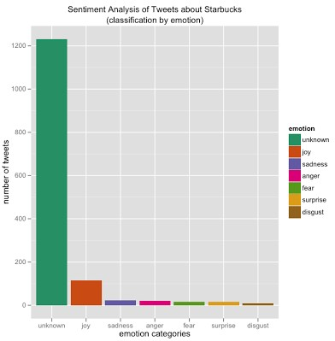

**Plot distribution of Polarity (positive, negative, neutral)**

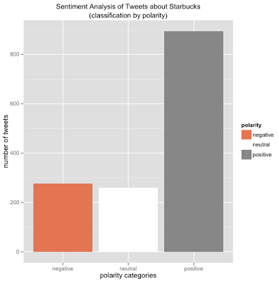

**LinkedIn Next 3 days Prediction using Machine Learning in R:**

* Loaded the linkedin dataset
* Create the days vector
* Fit a linear model called on the linkedin views per day: linkedin_lm
* Predict the number of views for the next three days: linkedin_pred
* Plot historical data and predictions

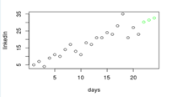

**Note: The green circles are the predicted values**